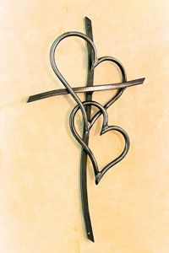
I choose today to love! Not the typical love standard by the world and its definition. But by a standard that is equal to those who chose to be guided by its reputation. I choose to love everyone and everything by what this perfect and purposed love created, for whom and by whom it was bestowed! I choose to love something or someone greater than I, because the team we used to assemble together as, is no longer the team I play for! I have been drafted and hand crafted for a mightier team! The salary was a fee that was paved and paid to set me free, like the 7th inning stretched, arms stretched on Calvary! Yes, I am in love with this team! Because this team chose me! In my ignorance It was bliss, earlier purposes I missed, taught by teachers whose rhetoric now dismissed! Maybe one day I could teach the era of new leaders and make disciples! Etch in their minds how to live breathe, and walk like the Bible! Teach how to love like the One who first loved me, but still take the time to pray for my enemies! Yes, I choose to love! The kind of love that pours from above! Descend on me like a dove! But I am not the one worthy of it, God you still show it! Just as clear as the Bible, I know it! I promise, I’ll own it!

